|  |  |  |
| --- | --- | --- |
| **Document Title**  _ac_title | **Document Number**  _ac_docnumber | **Version Number**  _ac_versionnumber |
| **Effective Date**  _ac_effectivedate | **Requested by**  _ac_requestedby | **Approved by**  _ac_approvedby |

Revision History

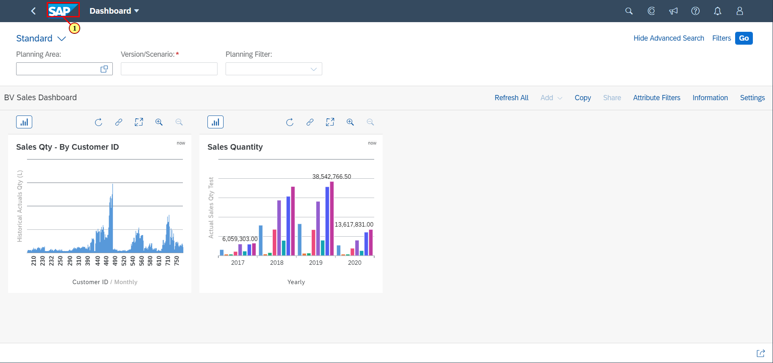

(1) Click on  **Home Page**

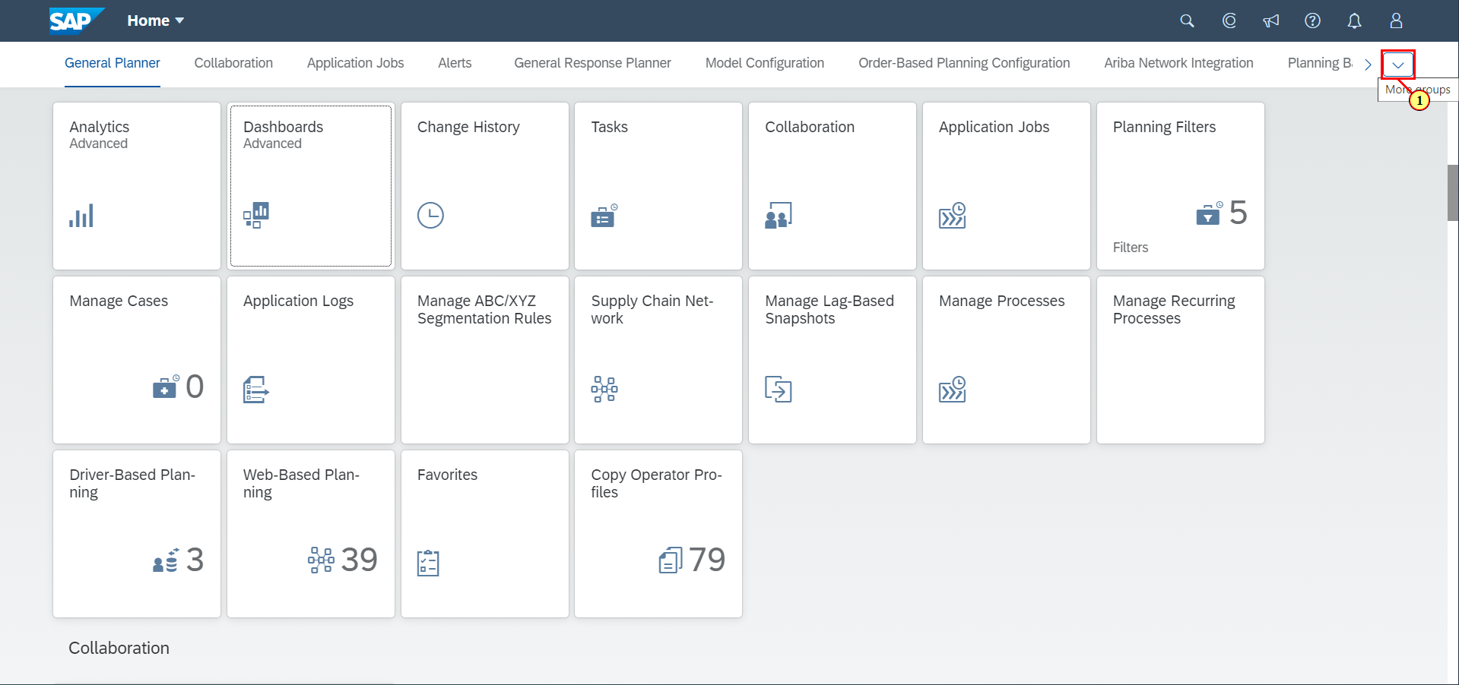

(1) Click on .

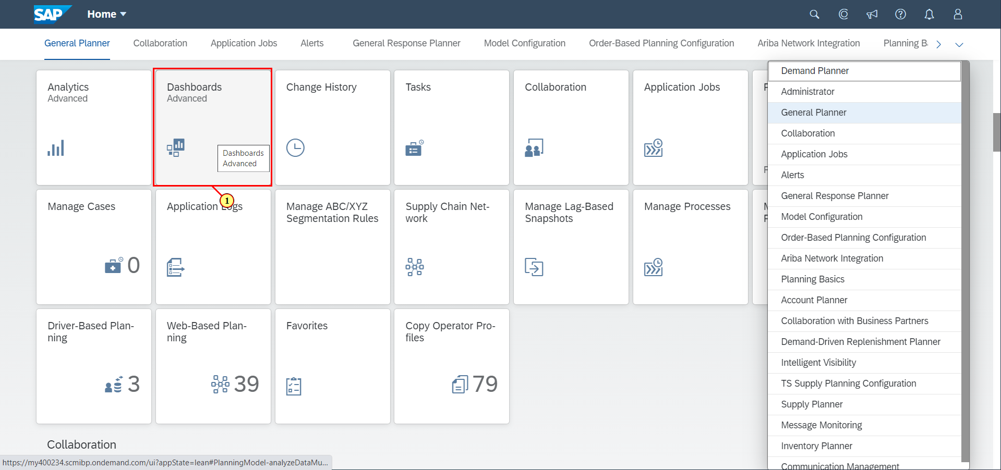

(1) Click on **Dashboards Advanced**.

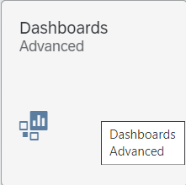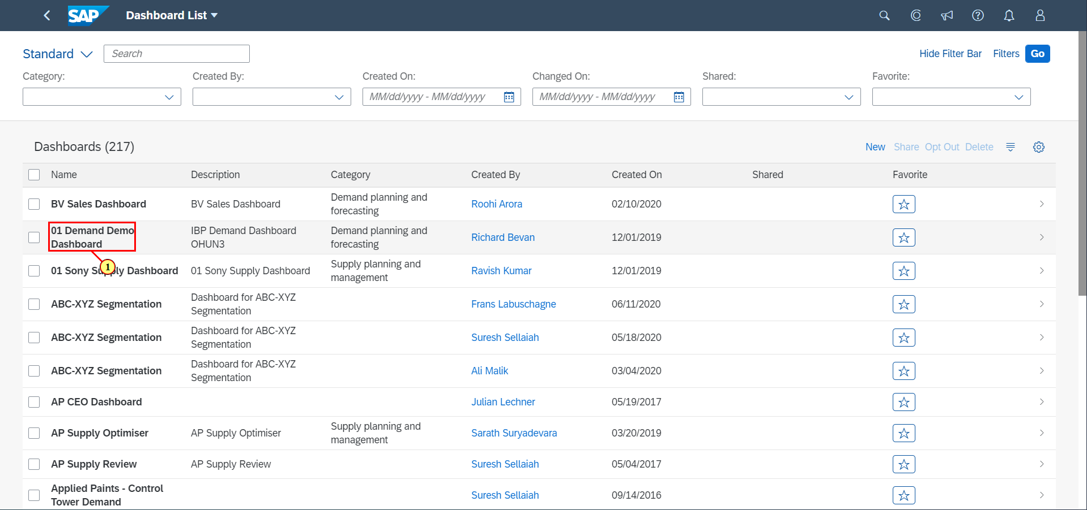

(1) Click on **01 Demand Demo Dashboard**.

